**COVID19 PREDICTION WITH DEEP LEARNING ON NEURAL NETWORKS**

**CS5720 NEURAL NETWORK DEEP LEARNING - PROJECT**

**Abstract:**

Coronavirus illness spreads quickly. Severe pneumonia is caused by COVID-19, which is thought to have a significant effect on the healthcare system. In order to provide accurate treatment, an early diagnosis is desperately needed, which eases the burden on the healthcare system. A chest X-ray (CXR) and a computed tomography (CT) scan are two common image diagnosis methods. While CT scans are still the gold standard for diagnosis, CXR is more commonly utilized since it is more accessible, quicker, and less expensive. With the use of CXR pictures, this study attempts to offer a method for distinguishing between pneumonia caused by COVID-19 and healthy lungs (normal person). The Deep Learning technique is one of the most amazing ways to extract a high dimensional feature from medical images. The most recent methods in this study include the use of genetic deep learning convolutional neural networks (GDCNNs). The system is trained from the beginning to extract features and classify photos into COVID-19 and normal categories. Pneumonia, normal pneumonia, and various pneumonia diseases are classified using a dataset of over 5000 CXR image samples. Training a GDCNN from scratch demonstrates that the suggested approach outperforms alternative transfer learning strategies. In COVID-19 prediction, 98.84% classification accuracy, 93% precision, 100% sensitivity, and 97.0% specificity are attained. The highest classification accuracy found in this study indicates the optimal nominal rate for COVID-19 disease prediction in an unbalanced setting. The new model that has been suggested for classification turns out to be superior to the models that are already in use, including Visual Geometry Group (VGG16), ReseNet18, ReseNet50, Squeezenet, and DenseNet-121.

**Key Words:** Genetic Deep Learning Convolutional Neural Network (GDCNN), Computed Tomography (CT), Chest X-Ray (CXR), Artificial Intelligence (AI)

1. INTRODUCTION

The novel coronavirus is officially known as severe acute respiratory syndrome. Coronavirus-2 (SARS-COV-2) is the cause of Coronavirus Disease 2019 (COVID-19). Fever, coughing, respiratory tract infections, and, in rare cases, pneumonia are some of the symptoms associated with COVID-19. The illness that irritates the oxygen-transferable air sacs of the lung is commonly referred to as pneumonia. Numerous viruses, bacteria, and fungi can also cause pneumonia. The elderly, smoking, weakened or compromised immune systems, and long-term illnesses like bronchitis or asthma are the main causes of the severity. Although the infected organism determines how the sick people are treated, patients are given cough medicine, painkillers, fever reducers, and antibiotics based on their symptoms. If the patient's condition is serious, they must be

admitted to the hospital and get treatment in the intensive care unit (ICU), which may require the use of a ventilator to help them breathe. The COVID-19 pandemic is a result of the virus's severity and quicker spread. Increased impact on the health care department is mostly caused by the increasing number of persons affected daily, as they are required to provide mechanical ventilation for seriously ill patients admitted to the intensive care unit. Hence, number of beds in ICU also need to be increased drastically. In the above situation, the initial diagnosis is vital for proper treatment which, in turn, reduces the pressure on the health care system. Artificial intelligence (AI) has enabled a major breakthrough in the identification of COVID-19 and other pneumococcal infections. Pneumonia is diagnosed with some routine imaging procedures, such as a computed tomography (CT) scan and a chest X-ray (CXR). Since CXR can lead to imprecise and erroneous diagnoses, it is the primary resource utilized to examine pneumonia cases. However, CXR is used because it is more affordable, recovers more quickly, exposes patients to less radiation, and is widely accessible in all healthcare systems. Since the majority of the water- or pus-filled air sacs as well as the white patches in the lungs must be examined, diagnosing pneumonia is challenging. As a result, it is difficult to distinguish between TB and bronchitis.

* 1. EASE OF USE

1. *PANDEMIC AND PNEUMONIA DISEASE COVID-19* After Wuhan, China, reported the first incidence of COVID-19, it didn't take long for the virus to begin spreading to other parts of the world. This suggests that the number of cases that are reported rises rapidly; there are currently over 8.24 million confirmed cases globally. COVID-19 Although epidemiological characteristics are still being investigated, data indicates that, on average, 80% of patients have mild conditions with few asymptomatic cases, and that 20% of patients have severe conditions; 10% of these patients must be in an intensive care unit (ICU) with ventilators..Since there aren't many ICU beds, the quantity of patients hospitalized is the main cause for concern. As COVID-19 affects the lung's pulmonary parenchyma—a region where gas is transferred—pneumonia is the main complication. There are also some other organisms, such as bacteria, viruses, and fungi. Since pneumonia is often thought of as a set of illnesses, multiple diagnostic techniques are required; as a result, chest X-ray images and CT scans are utilized to make the diagnosis.
2. *CLASSIFICATION OF CLASSES*

Binary, multi-class, and multi-label classification problems are all included in flat classification; however, multi-label classification incorporates many classes and has associated

IEEE 2023

outputs. The task of binary classification involves using classification rules to divide the images in the provided dataset into two groups. Random forests, decision trees, logistic regression, Bayesian networks, support vector machines, neural networks, and probit models are a few techniques utilized in categorization. The parameters description is displayed in Table 1 along with a symbol explanation. Equation illustrates how the features are represented by the symbol "x," which contains the set of parameters "x1,x2."

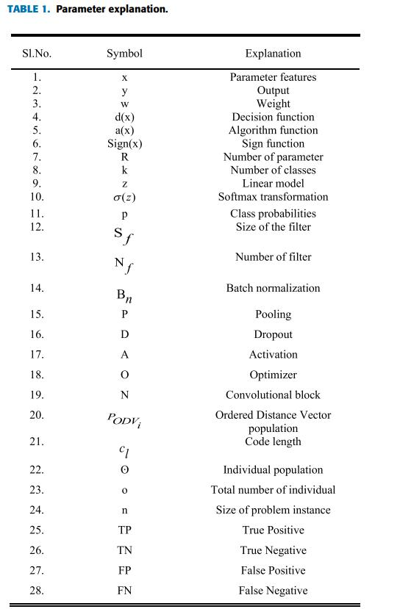

(1). 'y' denotes the output, as in equation

(2), Using the equation, a decision function based on the weight for each parameter is assessed.

(3). The equation represents the algorithm function.

1. TTherefore, the hierarchy established using an incomplete order set determines the number of parameters. Additionally, different approaches to solving hierarchical classification issues with reference to the labeling classification process are also covered. Local classifiers (LC) are a method that takes partial local information perception and hierarchy into account, enabling multi-class and binary classifiers to solve the problem locally. Moreover, based on the training dataset, the Global Classifier (GC) method creates a distinct classification model. When looking at the class hierarchy as a whole, the GC technique is frequently employed because substantial information about the pneumonia labels may be found throughout the hierarchy. Using the equation, "y" provides the multi-class classification result. It also states the number of parameters and the accuracy of the classification.

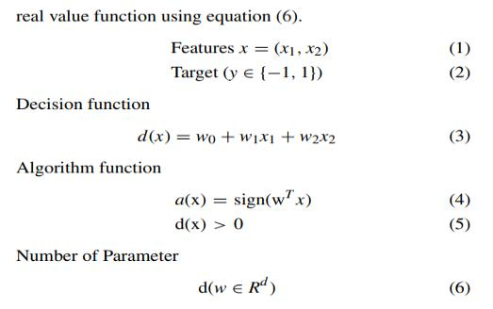

Given the background information provided above, it is

clear that many classes are used to classify pneumonia since

multiple features need to be retrieved from CXR pictures,

but only one label needs to be assigned.

Taxonomy is utilized to define a tree hierarchy based on an

incomplete order set, according to Silla et al. [10].

The many methods for resolving problems with hierarchical

classification in relation to labeling classification processes

are also discussed [11]. Multi-class and binary classifiers

can solve the problem locally thanks to the use of local

classifiers (LC), a technique that considers partial local

information perception and hierarchy [12], [13].

Additionally, a unique classification model called the Global

Classifier (GC) method was created utilizing the training

dataset. Considering the entire structure of classes, crucial

information Equation (7) provides the multi-class

classification output, equation (9) specifies the number of

parameters, and equation (10) provides the classification accuracy.

Multi class classification

The COVID-19 pandemic scenario in the healthcare system and the early causes of diagnosis are discussed in Section I. Section II lists the methods currently in use for COVID-19 prediction using Deep Learning Convolutional Neural Network models and picture categorization. The suggested Genetic Deep Learning Convolutional Neural Network, which uses population approaches based on Ordered Distance Vectors, is illustrated in Section III for the best possible COVID-19 prediction. The experimental study of the suggested work is presented in Section IV, where it is contrasted with the DCNN models already in use. The following parameters are employed in performance analysis: F1-score, recall, accuracy, specificity, and sensitivity. Final thoughts on the suggested GDCNN models for next projects.

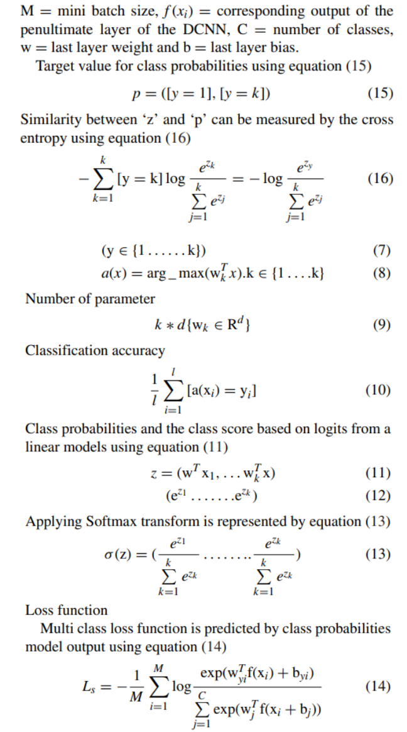

M = mini batch size, f (xi) = corresponding output of the penultimate layer of the DCNN, C = number of classes, w = last layer weight and b = last layer bias.

Target value for class probabilities using equation (15)

p = ([y = 1], [y = k]) (15)

Similarity between ‘z’ and ‘p’ can be measured by the cross entropy using equation (16)

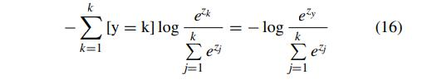

*C. IMBALANCENESS DATA AND RESAMPLING*

Most researchers have run into problems with class imbalance distribution when working with real datasets [16], [17]. Algorithms for classifiers focus on majority classes in order to minimize the total error rate. But they also focus on minority classes that are exclusive to the issue area, including medical picture categorization and credit card fraud detection [18], [19]. Using CXR images to identify the type of pneumonia is seen as unbalanced learning in the real world because there are fewer cases of pneumonia than there are healthy people [20], [21]. The number of people suffering from various types of pneumonia, however, is similarly unbalanced [22], [23].

**MOTIVATION:**

Precise and practical detection can reduce the death rate from lung diseases. Because there are not enough experienced radiologists, decisions and treatment are postponed. Another obstacle to timely discovery is the stark discrepancy between the number of experts and the population in a given area. Clinical staff's ability to make decisions can be improved by PC-supported analytical tools that combine deep learning and PC vision with radiological picture analysis to identify and eliminate patterns.

**OBJECTIVE**:

Predicting the Covid19 from chest x-ray pictures is the aim of Covid19 illness prediction. A set of x-ray images of Covid19 patients is used for training, together with x-ray photos of test subjects, before the outcomes are finally predicted.

**FEATURE**:

In the past 200 years, Covid19—a respiratory contamination caused by bacteria, viruses, or parasites—has been recognized as a rather common and potentially fatal disease. Motivated by the human specialists' finding method, we integrate clinical perception and clinical images. provide a need-based algorithm that synthesizes clinical data to create logical convolutional neural networks.

1. RELATED WORK

A comprehensive review of the various photo classification techniques is conducted. It was also described how the current CNN models employ CT and CXR images to predict COVID-19. The analysis's accuracy is provided for a variety of prediction models. The automation of DCNN architecture for image search and classification is thoroughly examined. Zhou et al. (2020) presented a deep learning algorithm based on CT scans to distinguish between influenza and new

coronavirus pneumonia. CT scans are better than CXR images even if they cost more since they may clearly show lung infection. Artificial intelligence (AI) was utilized by Li et al. [47] to detect COVID-19, leading to the creation of a dataset containing photos of COVID-19-afflicted individuals, various forms of pneumonia, and diagnoses of pneumonia. The images, which come from more than 400 COVID-19 patient images, 1396 viral pneumonia images, 2969 training set images, and 1173 non-pneumonia images, are collected from Chinese hospitals.

K. He, X. Zhang, et al. (2016) [34] state that the 3D learning model for the prediction of COVID-19, non-pneumonia, and various viral pneumonias is provided as input. The output of the prediction clearly shows that the AUROC value for other viral pneumonia is 0.95 and the AUROC value for COVID-19 is 0.96.

In order to identify COVID-19, Narin et al. in 2020 [48] employed CXR pictures along with three different deep neural networks: Inception-V3, ResNet50, and InceptionResNetV2. The collection, which consists of 100 CXR pictures, has 50 COVID-19 positive photos and 50 COVID-19 negative images. The outcome is validated using a fivefold cross; the Inception-ResNetV2 model yields 87% accuracy, the Inception-V3 model yields 97% accuracy, and the ResNet50 model yields 98% accuracy. In 2020, Gozes et al. identified the COVID-19 by using CT images as input for deep learning algorithms [49]. Patients' evolutions are completed with the help of 3D volume, yielding a corneal score. This work's main goal is to keep an eye on the COVID-19 epidemic. There are 157 CT pictures in the dataset, collected from China and the US. Furthermore, detection has been achieved using both 2D and 3D deep learning models, associated with clinical understanding, and requiring just minor adjustments to the existing AI algorithms. 0.996 AUROC for corneal and non-corona image separation.

Using CXR pictures, Wang et al. 2020 [50] created the open-source deep neural network COVID-Net, which is used to identify COVID-19. The dataset was created to make COVID-Net testing easier and comprises 16,756 patients. Network architecture, best practices, and human-driven design were combined to produce the COVID-Net architecture. There is an 80% detection rate, a 95% sensitivity rate, and a 92.4% accuracy rate. Using CXR pictures as the input, Khan et al. [51] developed CoroNet, a Convolutional Neural Network (CNN) for COVID-19 identification, in 2020. The Extreme Inception model, which uses 71 layers of trained images from the ImageNet dataset, serves as the basis for this model. It is discovered that the affected patients include 284 COVID-19, 327 viral, 310 normal patients, and 330 patients with bacterial infections. Since the dataset utilized in this method is not publicly available, the biggest problem with it is its average accuracy of 0.93 and 0.87 for F1-scores, respectively. Furthermore, the topic of the hierarchical classification is not covered. Since Ozturk et al. 2020 [52] proposed a deeper model for the identification of COVID-19 with CXR pictures, binary and multiclass classification is applied. The proposed model achieves 98.08% accuracy in binary classification and 87.02% accuracy in multi-class classification.

IV.METHOD

suggested an autonomous, continuous learning algorithm for building a DCNN architecture. The DCNN is divided into several weighted completely connected and meta-convolutional blocks as part of the process. Among the procedures offered in each block are pooling, convolution, batch normalization, dropout, completely connection, and activation operation. thereby converting the DCNN architecture into a shared integer code. Crossover, mutation, and selection are genetic mechanisms that evolve the population of DCNN designs. The proposed genetic DCNN design is helping the individual population to grow and develop.

For encoding, an appropriate DCNN architecture is also employed. The population is initialized at random via a random function. Furthermore, the effectiveness of the genetic DCNN encoding on certain image detection tasks is used to calculate each individual's fitness. To generate a new generation based on the present generation, genetic operators such as selection, crossover operator, and mutation are employed, which improvises overall fitness values. Generation after generation, iteratively, the evolution is carried out until it satisfies the requirements or for a predetermined number of generations.

*A. Encoding Scheme*

A chromosomal locus guided the development of the proposed genetically based DCNN architecture. Chromosomes are consequently divided into the q-arm and p-arm. The loci that are known for a certain genome are referred to as the "gene map".As a result, it is clear that all of DCNN's encoding operations are based on gene maps. The loci on a chromosome are observed as the operations that DCNN must do. Convolutional blocks basically perform five key operations: pooling, normalizing, dropout, and activation.

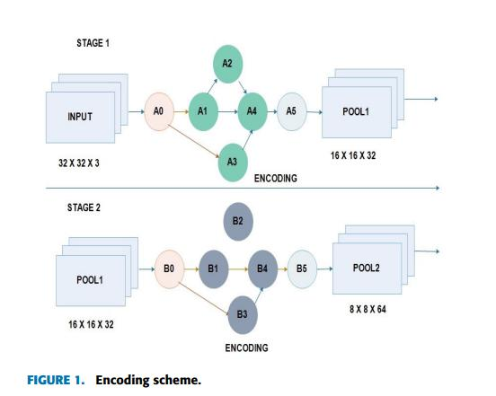

Table 2 shows the range of values at every locus of the code, (Nf ) various from 16 to 512, Sf are 7 × 7, 5 × 5 and 3

* 3, pooling operation is indicated by three values they are 0, 1 and 2. ‘0’ denotes no pooling, ‘1’ state’s maximum pooling and ‘2’ for average pooling. Usually Bn take the value ‘1’ and ‘0’, ‘1’ indicates batch normalization is

performed and ‘0’ not performed. ‘A’ various from 0 to 5 stating ELU [2], ReLU [8], PReLU [12], TReLU [18], softmax and LeakyReLU [22]. The value of ‘O’ ranges from 0 to 6 denoting SGD [6], Adadelta [17], Adamax [31], Adam [31], Adagrad [35] and RMSprop [36]. Thus, based on the coding scheme p-arm contains the sequence [Nf Sf Bn PDA] [Nf Sf Bn] and q-arm sequence is [Nf Sf Bn DA].

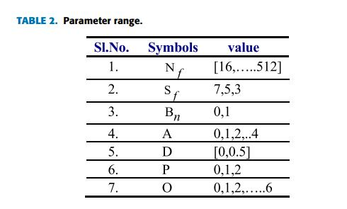

It is evident that if the cross point is "ki," located at "3lc + 1," then "8" learnable layers are needed, and if the cross point is "kj," located at "5lc + 1," then "11" learnable layers are needed. Moreover, as equations (22) and (23) demonstrate, the number of layers needed for DCNN following crossover operation is 9 and 10, respectively.

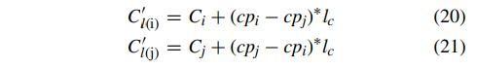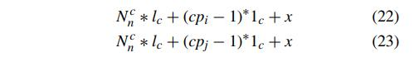

*B. INTIALIZATION*

Population initialization techniques for Ordered Distance Vectors are utilized, including stochasticity, individual variability, and potential order. This is demonstrated by using equation (17). These populations have more potential for image permutation and individual variety because they are formed independently. It is a better, more effective approach with a quicker convergence time as a result..

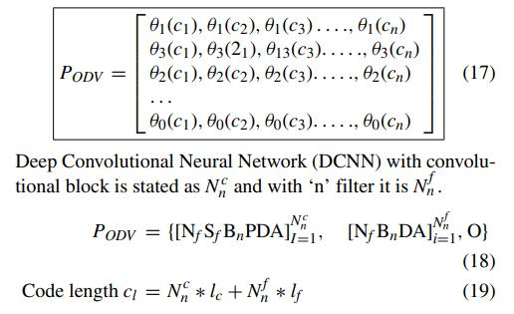

*C. CROSS OVER OPERATOR*

To split the DCNN architecture into two halves, a random point is chosen from a pair of DCNN PODVi and PODVj. By switching them, two new DCNN segments—P 0 ODVi and P 0 ODVj—are created; as a result, the depth differs from that of the parents. Assume that the convolutional arm picked in the "[Nf BnDA]" convolutional blocks has the cross point "ki" chosen within it.The formula for PODVi position is "(cpi − 1)**∗** lc + x." In a similar manner, the position of the other convolutional arm, cpj, is expressed as (cpj−1)**∗**lc+x. The cross operator's code length can be obtained using equations (20) and (21).

*D. MUTATION*

By using the mutation operator, the CNN's architecture is altered while maintaining its intergenerational variety. The new DCNN architecture for the population 'PODV' is accelerated in the interval [8 Ln, 0.5] by 'qm'. The convolutional block will change (for example, from 7 × 7 to 5 × 5 or from 5 × 5 to 3 × 3) after the mutation process is complete. In exceptional cases, the batch normalization process in the fifth convolutional layer will shift from 327 to 513, and the max pooling layer may also be removed. Additionally, change your optimizer from Nadam to RMSprop. The proposed GDCNN designer is shown in Figure 2, where CXR image samples are initialized and an acceptable encoding strategy is used to try to improve each individual population.

1. *GENETIC DEEP CONVOLUTION NEURAL NETWORK ALGORITHM*

Population initialization, a procedure used in the genetic DCNN design architecture, involves randomly starting a population. This allows the population to grow generation by generation in order to create better architectures with the use of redesigned genetic operations. Creating a random operation and carrying out a batch normalizing procedure are part of the selection operation. Training the GDCNN model to achieve a fitness value involves processing the feeding population's activation through a convolution neural network and maxpooling. Moreover, a generator is used to build model fitness. There is crossover, selection, and mutation activation. Two image classification data sets are used to assess the suggested method for differentiating between pneumonia, COVID-19, normal, and other pneumonia illnesses. Our findings demonstrate that the suggested genetic-based DCNN design functions admirably and on par with the state of the art.

ALGORITHM

Input: 5000 chest x-ray images (collection of images, training and test data).

Output: Accuracy, sample loss, val _loss,val_acc.

Step1: Initialization Input the 5000 chest x-ray images (training and test data)

Step2: Create random operation

Batch Normalization process

Step3: Feed population to Convolution neural network Activation,

conv2D(512, (3 x 3 ), padding = same, usebias = false)

maxpooling (pool size = (3, 3)

Dropout

Step4: Train GDCNN and get its fitness modelfit:generator(datagen.flow(x train, y train, batch size = batch = size),steps per epoch = x train,shape[0](batch size, epoch = epochs,validation data = (x test, y test), callbacks = [plot]) else modelfit:(x train, y train, batch size = batch size, epoch = epochs, validation data = (x test, y test), shuffle = true, callbacks = [plot]

Step 5: selection, crossover, mutation

Activation, conv2D (512, (3 × 3), padding = same, use bias = false) maxpooling (pool size = (3, 3) Dropout

Step 6: New populations train GDCNN and get its fitness Evaluate solution based on fitness value

Step 7: Check optimal solution based of fitness function If (optimal solution == fitness value) Optimal solution obtained

Step 8: Fitness value (optimal solution) Return optimal solution.

*A.DATASET*

Since the dataset was gathered from publications with chest x-ray images from all over the world, caution must be used to confirm the labeling with board-certified radiologists. The dataset is made up of radiologists' clear-sign chest x-ray samples; as a result, only anterior-posterior pictures are included in these samples.

*B.DATA LIMITATIONS*

Since the dataset only includes tiny samples of COVID-19-positive cases, it is also necessary to investigate patients who have significant symptoms. Additionally, cases with little symptoms are absent, and some individuals are even placed in confinement without a medical examination.

*C.ACCURACY*

One of the key measures used to assess classification models is accuracy, which is defined as the ratio of COVID-19 correct predictions to all prediction samples. Accuracy indicates if our model is correct or not. Equation 24 can be used to calculate the accuracy rates' confidence interval.



*E.SPECIFICITY*

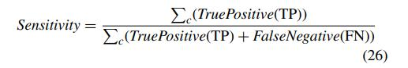

Specificity is defined as the True Positive (TP) to the sum of True Positive (TP) and False Positive (FP). Calculated using equation (27),

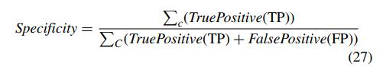

*G.RECALL*

Recall is measured as the summation of all class True Positive (TP) to the summation of class True Positive (TP) and False Negative (FN), it is stated by the equation (17)

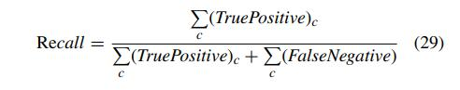

*H.F1-SCORE*

The precision and recall balance is measured using the F1-score. Moreover, it is expressed as the product of recall and precision multiplied by two in addition to the total product and sensitivity. The precision calculation is expressed in Equation (30).



*I CONFUSION MATRIX*

*The model's overall performance is provided by the confusion matrix, and a matrix is used to display the result. Figure 3's confusion matrix clearly shows that the number 3430 corresponds to a normal person—those who are not impacted by COVID-19. Out of the people, 20 have a COVID-19 infection that is likely, 12 may have COVID-19, and 443 have a COVID-19 infection that is confirmed.*

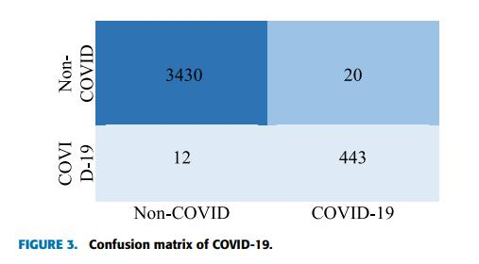

As illustrated at the bottom of the page, accuracy can alternatively be expressed as the total of True Positive (TP) and True Negative (TN) to the sum of True Positive (TP), True Negative (TN), False Positive (FP), and False Negative (FN) using equation (25).

*D.SENSITIVITY*

Since specificity and sensitivity serve as benchmark metrics for assessing classification performance, sensitivity measures True Positive (TP) to the total of False Negative (FN) and True Positive (TP). It is therefore provided by equation (26)

*K.EXPECTED OUTCOMES*

The tool, which was created using the GDCNN model, is incredibly beneficial to doctors and gives them confidence to treat COVID-19 patients while they wait for the radiologist to confirm their second opinion. It also offers a quantifiable score that may be taken into account and applied in research projects.

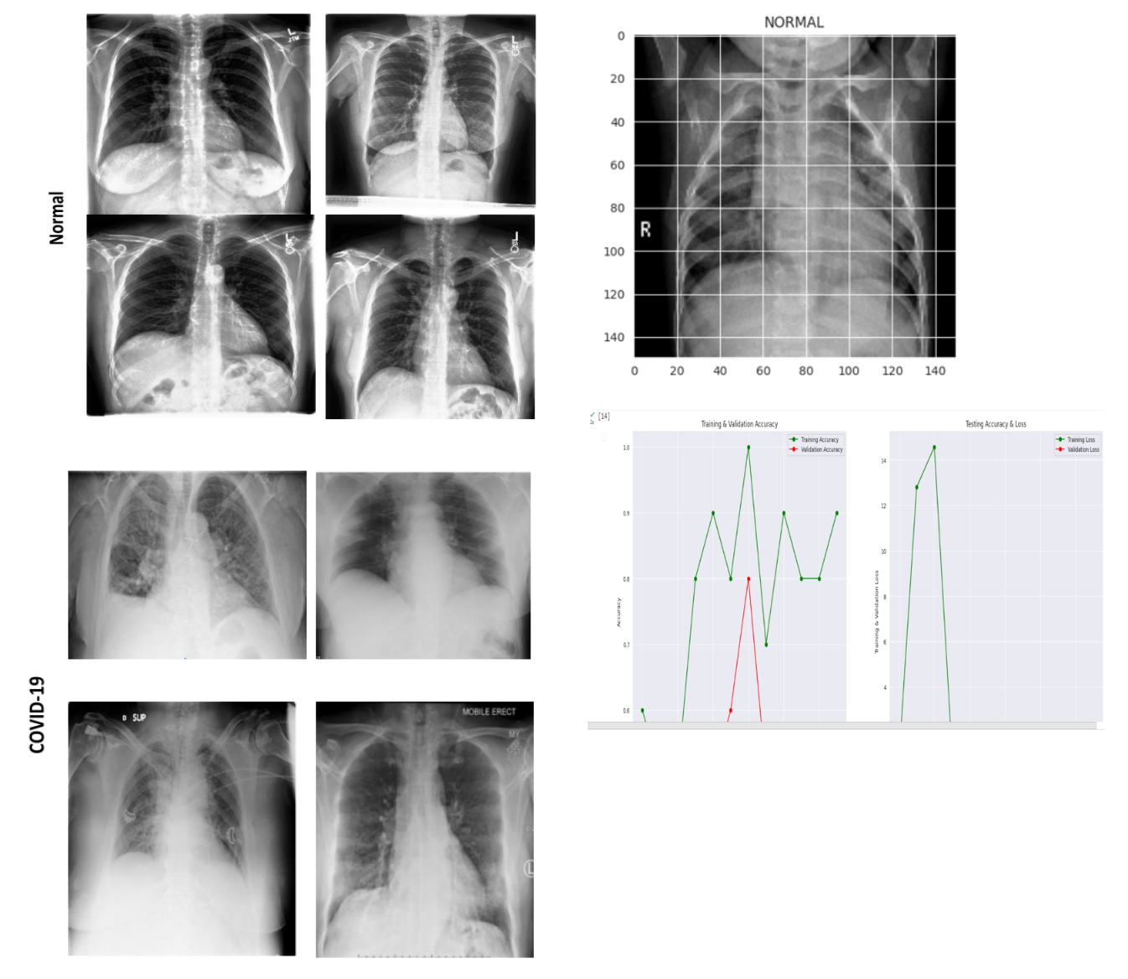

V. CONCLUSION

Owing to the exponential increase in cases and the quick dissemination of COVID-19, a pandemic is sweeping the globe. Early diagnosis of problems is essential for faster and more cost-effective COVID-19 treatment. In the above situation, samples of CXR pictures are used to train a deep learning model to predict COVID-19. In the real world, very few people are affected by pneumonia and many do not get

RESULTS/ANALYSIS it. Consequently, the probability of pneumonia is

asymmetric between the sick and healthy individuals. This

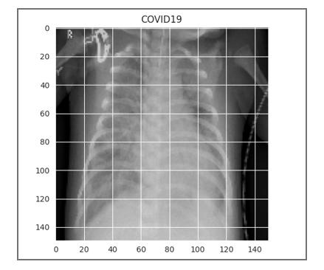

work proposes the GDCNNN technique to classify

COVID-19 and normal individuals using CXR image data.

Over 5000 image samples, including views of healthy lungs,

photos of pneumonia, and images of other conditions

associated to pneumonia, are available for public access in

the library. With an F1-score of 0.96337, Val accuracy of

0.99 (99.0%), loss of 0.32, and val_loss of 0.05, the

recommended technique can be accomplished. Furthermore,

to evaluate the performance of the proposed model, a

comparison is made with other existing models, such as

resenet18, resenet50, SqueezeNet, Densenet-121, and

VGG16.

It is clear from the analysis table that the recommended strategy outperforms the existing model. The study's main objectives are to enhance the detection rate for COVID-19 prediction at an earlier stage of diagnosis and to promote patient assistance in the early phases of treatment. The business can utilize this model to forecast things early. COVID-19, a GDCNN tool, is housed in a cloud computing setup. This tool can assist the healthcare system in making early diagnoses. In the future, we plan to apply this

technique to enhance the hierarchical classification accuracy on a large-scale database.

REFERENCES

1. Shreyas Setlur Arun , Ganesh Neelakanta Iyer ,“On the Analysis of COVID19 - Novel Corona Viral Disease Pandemic Spread Data Using Neural networks Techniques”, Proceedings of the International Conference on Intelligent Computing and Control Systems (ICICCS

2020) IEEE Xplore Part Number:CFP20K74-ART; ISBN:

978-1-7281-4876-2

1. Mazin Abed Mohammed;Karrar Hameed Abdulkareem;Alaa S. Al-Waisy; Salama A. Mostafa;Shumoos Al-Fahdawi;Abdullah BAZ “Benchmarking Methodology for Selection of Optimal COVID-19 Diagnostic Model Based on Entropy and TOPSIS Methods”, IEEE ACCESS.2020.2995597.
2. “Survival Analysis of COVID-19 Patients With Symptoms Information by Neural networks Algorithms”, IEEE Access, date of publication June 13, 2022, date of current version June 16, 2022. Digital Object Identifier 10.1109/ACCESS.2022.3182350.
3. Diagnosis of covid-19 and its clinical spectrum dataset. url=https://kaggle.com/einsteindata4u/covid19.
4. WHO Director-General’s remarks at the media briefing on 2019-nCoV on 11 February 2020. Library Catalog: www. who.int.
5. WHO EMRO | Questions and answers | COVID-19 | Health topics.
   1. Support Vector Machine Neural networks algorithm with example and code, January 2019. Library Catalog: www.cod ershood.info Section: Neural networks.
6. Ali Al-Hazmi. Challenges presented by MERS corona virus, and SARS corona virus to global health. Saudi journal of biological sciences, 23(4):507–511, 2016. Publisher: Elsevier.
7. Sina F Ardabili, Amir Mosavi, Pedram Ghamisi, Filip Ferdinand, Annamaria R Varkonyi-Koczy, Uwe Reuter, Timon Rabczuk, and Peter M Atkinson. Covid-19 outbreak prediction with neural networks. Available at SSRN 3580188, 2020.
   * 1. Hiba Asri, Hajar Mousannif, Hassan Al Moatassime, and Thomas Noel. Using neural networks algorithms for breast cancer risk prediction and diagnosis. Procedia Computer Science, 83:1064–1069, 2016.
   1. Taiwo Oladipupo Ayodele. Types of neural networks algorithms. New advances in neural networks, pages 19–48, 2010.
8. Taiwo Oladipupo Ayodele. Types of neural networks algorithms. New advances in neural networks, pages 19–48, 2010. Publisher: InTech.
9. David W Bates, Suchi Saria, Lucila Ohno-Machado, Anand Shah, and Gabriel Escobar. Big data in health care: using analytics to identify and manage highrisk and high-cost patients. Health Affairs, 33(7):1123–1131, 2014..
10. Hetal Bhavsar and Amit Ganatra. A comparative study of training algorithms for supervised neural networks. International Journal of Soft Computing and Engineering (IJSCE), 2(4):2231–2307, 2012.
11. Rich Caruana and Alexandru Niculescu-Mizil. An empirical comparison of supervised learning algorithms. In Proceedings of the 23rd international conference on Neural networks, pages 161–168, 2006.
    1. Nanshan Chen, Min Zhou, Xuan Dong, Jieming Qu, Fengyun Gong, Yang Han, Yang Qiu, Jingli Wang, Ying Liu, Yuan Wei, et al. Epidemiological and clinical characteristics of 99 cases of 2019 novel coronavirus pneumonia in wuhan, china: a descriptive study. The Lancet, 395(10223):507–513, 2020.
       * 1. Dursun Delen. Analysis of cancer data: a data mining approach. Expert Systems, 26(1):100–112, 2009.
12. Manoj Durairaj and Veera Ranjani. Data mining applications in healthcare sector: a study. International journal of scientific & technology research, 2(10):29– 35, 2013.
13. Ashok Kumar Dwivedi. Performance evaluation of different neural networks techniques for prediction of disease. Neural Computing and Applications, 29(10):685–693, 2018.